Altered amino acid profiles of the “mother–fetus” system in COVID-19
Lomova NA.¹, Chagovets VV¹, Dolgopolova EL¹, Novoselova AV¹, Petrova UL¹, Shmakov RG¹, Frankevich VE¹
¹Kulakov National Medical Research Center for Obstetrics, Gynecology and Perinatology, Moscow, Russia

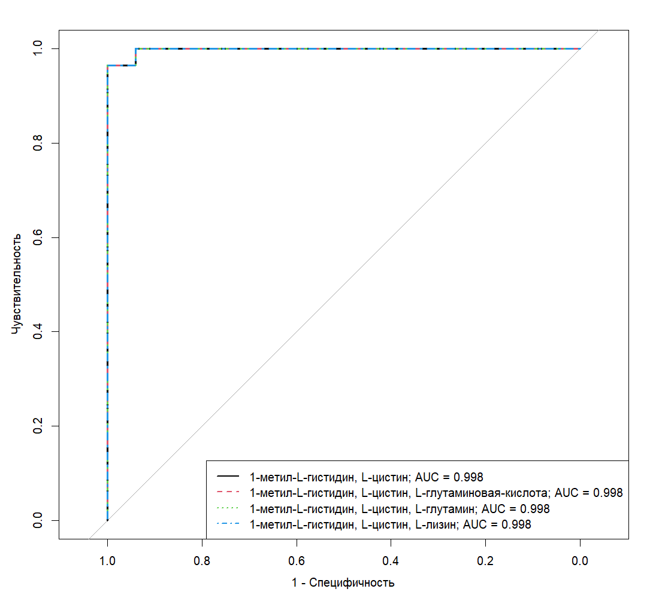
Fig. S1. ROC-curves of the logistic regression models using amino acid concentrations in the venous blood plasma for differentiation between the control and COVID-19 groups of the study

метил — methyl; гистидин — histidine; цистин — cystine; глутаминовая кислота — glutamic acid; глутамин — glutamine; лизин — lysine; Чувствительность — Sensitivity; Специфичность — Specificity
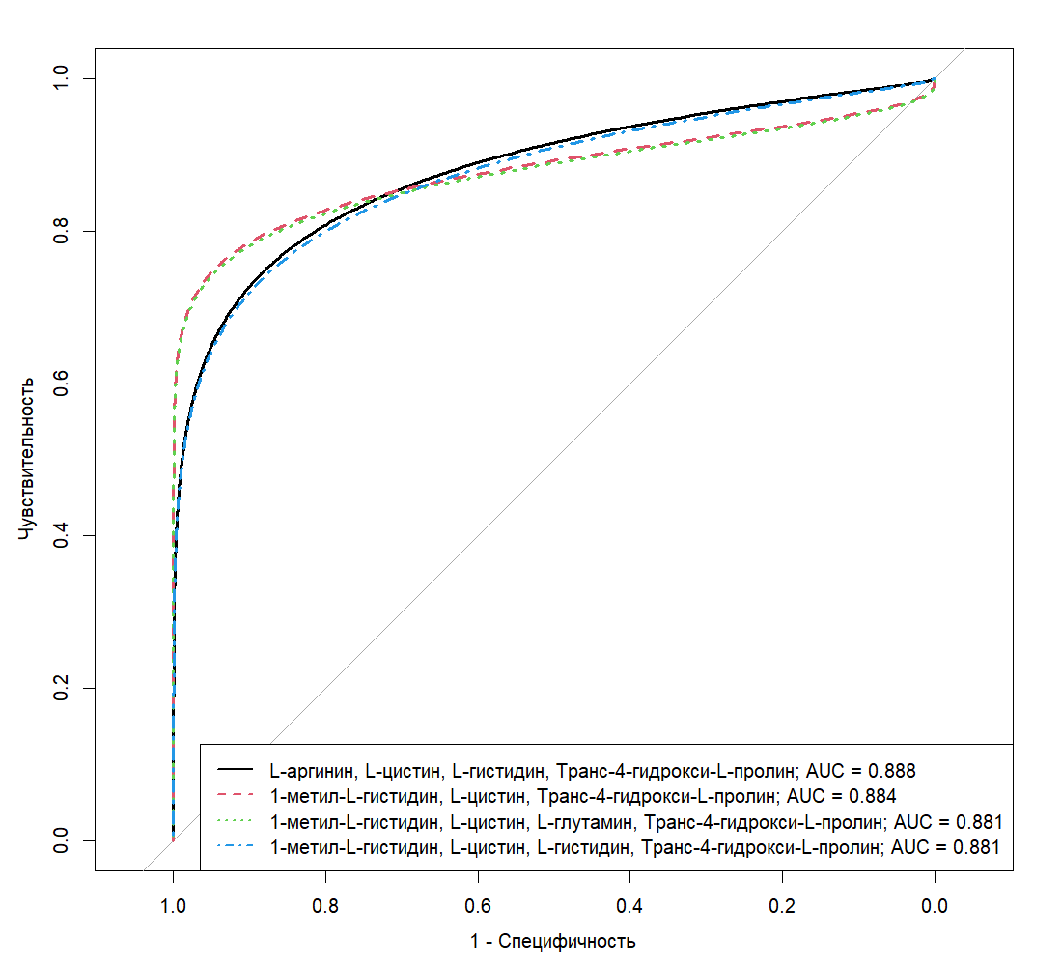

Fig. S2. ROC-curves of the logistic regression models using amino acid concentrations in the amniotic fluid for differentiation between the control and COVID-19 groups of the study

аргинин — arginine; цистин — cystine; гистидин — histidine; метил — methyl; глутамин — glutamine; Транс-4-гидрокси-L-пролин — trans-4-hydroxy-L-proline; Чувствительность — Sensitivity; Специфичность — Specificity
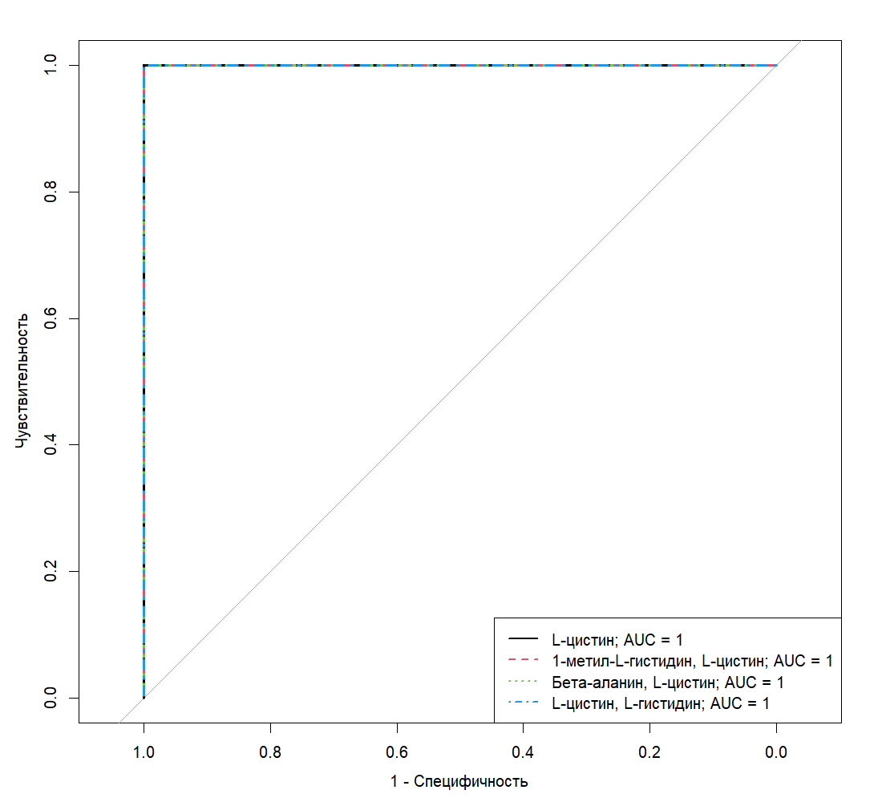
Fig. S3. ROC-curves of the logistic regression models using amino acid concentrations in the umbilical cord blood plasma for differentiation between the control and COVID-19 groups of the study

цистин — cystine; гистидин — histidine; метил — methyl; Бета-аланин — β-alanine; Чувствительность — Sensitivity; Специфичность — Specificity

Table S1. Amino acid concentrations (nmol/mL) in the venous blood plasma for the control and COVID-19 groups of the study
Amino acid | Control | COVID-19 | p-value
1-Methyl-L-histidine | 0.98 (0; 6.71) | 0 (0; 0) | 0.002
3-Methyl-L-histidine | 4.78 (4.36; 5.08) | 4.9 (4.48; 5.22) | 0.453
3-Aminoisobutyric acid | 2.44 (1.98; 3.31) | 2.87 (1.52; 4.85) | 0.609
DL-5-Hydroxylysine | 9.5 (9.46; 9.56) | 9.52 (9.48; 9.54) | 0.837
Ethanolamine | 0 (0; 0.12) | 0.01 (0; 0.66) | 0.432
L-2-Aminobutyric acid | 5.32 (3.79; 8.12) | 6.62 (5.56; 8.33) | 0.167
L-Alanine | 403.88 (334.36; 430) | 366.38 (300.04; 436.23) | 0.417
L-Arginine | 15.1 (13.4; 24.76) | 24.05 (19.32; 30.58) | 0.080
L-Asparagine | 39.18 (35.55; 48.52) | 40.93 (37.2; 46.25) | 0.753
L-Aspartic acid | 8.76 (6.69; 13.61) | 7.72 (6.8; 8.96) | 0.280
L-Carnosine | 4.5 (4.31; 4.99) | 4.37 (4.34; 4.59) | 0.509
L-Citrulline | 13.62 (11.06; 17.81) | 14.22 (11.29; 15.72) | 0.839
L-Cystathionine | 0.52 (0.47; 0.65) | 0.54 (0.48; 0.68) | 0.554
L-Cystine | 30.01 (25.43; 36.2) | 11.07 (7.83; 13.61) | < 0.001
L-Glutamic acid | 204.03 (169.08; 221.46) | 238.1 (203.76; 250.6) | 0.042
L-Glutamine | 461.74 (441.66; 492.15) | 508.36 (465.78; 586.27) | 0.050
L-Glycine | 140.45 (101.72; 184.43) | 133.56 (116.54; 152.73) | 0.946
L-Histidine | 161.33 (129.56; 191.57) | 133.56 (106.61; 163.51) | 0.174
L-Lysine | 151.14 (125.64; 168.06) | 172.1 (159.03; 194.55) | 0.026
L-Methionine | 22.28 (15.99; 24.85) | 21.37 (17.93; 25.12) | 0.702
L-Ornithine | 47.93 (40.72; 60.26) | 37.06 (32.41; 48.79) | 0.160
L-Phenylalanine | 51.05 (46.82; 54.58) | 48.37 (43.28; 55.22) | 0.239
L-Proline | 127.47 (113.22; 146.58) | 112.18 (104.31; 142.51) | 0.457
L-Serine | 76.86 (52.97; 85.49) | 77.24 (66.04; 82.69) | 0.573
L-Threonine | 192.03 (159.82; 235.76) | 198.65 (181.41; 251.54) | 0.457
L-Tryptophan | 34.46 (27.82; 44.11) | 32.88 (25.16; 39.45) | 0.367
L-Tyrosine | 42.64 (34.38; 49.59) | 36.24 (31.95; 44.61) | 0.165
Taurine | 9.23 (7.96; 11.28) | 9.73 (8.7; 11.44) | 0.357
Trans-4-hydroxy-L-proline | 11.84 (10.89; 13.2) | 11.15 (10.49; 11.94) | 0.219

Table S2. Parameters of the logistic regression models allowing differentiation of patients with COVID-19 from healthy controls by amino acid content of the venous blood plasma
Model # | Term | Coefficient | Wald test value | p-value (95% CI) | OR (95% CI)
1 | Constant term | 31.54 | 1.48 | 0.14 (9.51; 105.84) | 4.9∙10¹³ (1.3∙10⁴; 9.2∙10⁴⁵)
 | 1-Methyl-L-histidine | ‒1.00 | ‒1.29 | 0.20 (‒4.05; ‒0.11) | 0.37 (0.02; 0.90)
 | L-Cystine | ‒1.54 | ‒1.49 | 0.14 (‒5.13; ‒0.46) | 0.22 (0.01; 0.63)
2 | Constant term | 20.16 | 0.92 | 0.36 (‒2.03; 104.31) | 5.7∙10⁸ (0.13; 2.01∙10⁴⁵)
 | 1-Methyl-L-histidine | ‒0.92 | ‒1.10 | 0.27 (‒; ‒0.07) | 0.40 (‒; 0.93)
 | L-Cystine | ‒1.30 | ‒1.40 | 0.16 (‒4.93; ‒0.39) | 0.27 (0.01; 0.68)
 | L-Glutamic acid | 0.03 | 0.40 | 0.69 (‒0.01; 0.35) | 1.03 (0.99; 1.42)
3 | Constant term | 20.73 | 0.79 | 0.43 (‒14.74; 109.50) | 1.01∙10⁹ (0.00; 3.58∙10⁴⁷)
 | 1-Methyl-L-histidine | ‒0.84 | ‒1.09 | 0.28 (‒; ‒0.04) | 0.43 (‒; 0.96)
 | L-Cystine | ‒1.21 | ‒1.21 | 0.23 (‒5.02; ‒0.38) | 0.30 (0.01; 0.68)
 | L-Glutamine | 0.01 | 0.38 | 0.71 (‒0.02; 0.11) | 1.01 (0.98; 1.12)
4 | Constant term | 27.54 | 0.94 | 0.35 (0.13; ‒) | 9.09∙10¹¹ (1.14; ‒)
 | 1-Methyl-L-histidine | ‒1.15 | ‒0.85 | 0.39 (‒; ‒0.04) | 0.32 (‒; 0.96)
 | L-Cystine | ‒1.54 | ‒1.01 | 0.31 (‒; ‒0.51) | 0.21 (‒; 0.60)

Table S3. Validation of the logistic regression models allowing differentiation of patients with COVID-19 from healthy controls by amino acid content of the venous blood plasma
Amino acid | AUC | Threshold value | Sensitivity | Specificity | Positive predictive value
1-Methyl-L-histidine, L-cystine | 1 | 0.78 | 1 (0.93; 1) | 1 (0.94; 1) | 1 (0.97; 1)
1-Methyl-L-histidine, L-cystine, L-glutamic acid | 1 | 0.75 | 1 (0.93; 1) | 1 (0.94; 1) | 1 (0.97; 1)
1-Methyl-L-histidine, L-cystine, L-glutamine | 1 | 0.75 | 1 (0.93; 1) | 1 (0.94; 1) | 1 (0.97; 1)
1-Methyl-L-histidine, L-cystine, L-lysine | 1 | 0.7 | 1 (0.93; 1) | 1 (0.94; 1) | 1 (0.97; 1)

Table S4. Amino acid concentrations (nmol/mL) in the amniotic fluid for the control and COVID-19 groups of the study
Amino acid | Control | COVID-19 | p-value
1-Methyl-L-histidine | 9.52 (5.78; 23.54) | 0 (0; 4.98) | < 0.001
3-Methyl-L-histidine | 1.32 (0.14; 2.56) | 1.62 (0.48; 5.35) | 0.258
3-Aminoisobutyric acid | 7.44 (6.38; 9.22) | 5.48 (4.4; 6.17) | 0.002
DL-5-Hydroxylysine | 10.31 (9.98; 10.69) | 10.28 (9.99; 10.5) | 0.591
Ethanolamine | 45.69 (38.94; 67.65) | 35.24 (24.53; 46.3) | 0.096
L-2-Aminobutyric acid | 1.5 (1.27; 2.34) | 1.27 (1; 2.62) | 0.367
L-2-Aminoadipic acid | 7.21 (5.39; 10.59) | 6.66 (5.24; 9.46) | 0.615
L-Alanine | 238.74 (179.29; 329.59) | 187.36 (136.91; 257.72) | 0.302
L-Arginine | 26.59 (22.42; 48.86) | 16.25 (8.97; 23.61) | 0.006
L-Asparagine | 29.36 (24.49; 40.74) | 25.56 (19.32; 41.31) | 0.391
L-Aspartic acid | 13.82 (7.9; 29.75) | 11.92 (6.64; 62.9) | 0.784
L-Carnosine | 4.58 (4.43; 5.21) | 5.5 (4.54; 6.31) | 0.107
L-Citrulline | 8.6 (6.93; 11.43) | 7.57 (4.84; 14.52) | 0.632
L-Cystathionine | 0.96 (0.83; 1.16) | 0.8 (0.56; 0.96) | 0.036
L-Cystine | 39.69 (30.93; 46.09) | 15.92 (5.48; 35.06) | 0.005
L-Glutamic acid | 176.3 (114.37; 215.51) | 112.92 (67.26; 176.17) | 0.15
L-Glutamine | 392.48 (267.94; 450.24) | 286.57 (177.62; 369.67) | 0.044
L-Glycine | 216.37 (189.39; 359.66) | 219.92 (156.65; 260.22) | 0.43
L-Histidine | 65.35 (34.72; 85.64) | 7.9 (0; 30.68) | 0.008
L-Lysine | 153.56 (113.59; 169.06) | 149.15 (105.52; 187.74) | 0.973
L-Methionine | 16.55 (10.59; 20.68) | 11.21 (7.36; 19.59) | 0.252
L-Ornithine | 24.16 (15.39; 34.42) | 42.8 (20.11; 69.65) | 0.096
L-Phenylalanine | 39.63 (24.82; 51.44) | 32 (21.48; 55.77) | 0.515
L-Proline | 118.37 (103.97; 154.61) | 109.16 (72.85; 125.35) | 0.137
L-Serine | 65.52 (37.24; 89.78) | 50.74 (32.72; 95.85) | 0.681
L-Threonine | 150.1 (101.89; 211.52) | 136.31 (96.46; 172.32) | 0.445
L-Tryptophan | 11.63 (7.7; 13.69) | 7.49 (4.36; 14.33) | 0.302
L-Tyrosine | 24.3 (17.75; 38.24) | 18.23 (8.22; 47.62) | 0.435
L-Valine | 378.17 (286.06; 544.61) | 412.5 (256.16; 570.82) | 0.681
Taurine | 12.6 (11.48; 14.32) | 12.66 (11.54; 16.48) | 0.958
Trans-4-hydroxy-L-proline | 18.03 (14.18; 20.08) | 13.54 (11.05; 15.96) | 0.019

Table S5. Parameters of the logistic regression models allowing differentiation of patients with COVID-19 from healthy controls by amino acid content of the amniotic fluid
Model # | Term | Coefficient | Wald test value | p-value (95% CI) | OR (95% CI)
1 | Constant term | 5.88 | 2.34 | 0.02 (1.82; 11.88) | 357.17 (6.16; 144863.87)
 | L-Arginine | 0.01 | 0.37 | 0.71 (‒0.04; 0.06) | 1.01 (0.96; 1.06)
 | L-Cystine | ‒0.08 | ‒2.24 | 0.03 (‒0.17; ‒0.02) | 0.92 (0.84; 0.98)
 | L-Histidine | 0.01 | 1.16 | 0.24 (‒0.01; 0.04) | 1.01 (0.99; 1.04)
 | Trans-4-hydroxy-L-proline | ‒0.25 | ‒1.79 | 0.07 (‒0.57; 0.00) | 0.78 (0.56; 1.00)
2 | Constant term | 2.77 | 1.72 | 0.08 (‒0.11; 6.37) | 15.95 (0.89; 584.00)
 | 1-Methyl-L-histidine | ‒0.03 | ‒1.27 | 0.20 (‒0.11; 0.01) | 0.97 (0.90; 1.01)
 | L-Cystine | ‒0.01 | ‒0.52 | 0.60 (‒0.06; 0.03) | 0.99 (0.94; 1.03)
 | Trans-4-hydroxy-L-proline | ‒0.11 | ‒1.04 | 0.30 (‒0.34; 0.10) | 0.89 (0.71; 1.10)
3 | Constant term | 2.72 | 1.69 | 0.09 (‒0.15; 6.37) | 15.23 (0.86; 582.40)
 | 1-Methyl-L-histidine | ‒0.03 | ‒1.28 | 0.20 (‒0.11; 0.01) | 0.97 (0.90; 1.01)
 | L-Cystine | ‒0.02 | ‒0.53 | 0.59 (‒0.08; 0.04) | 0.98 (0.92; 1.04)
 | L-Glutamine | 0.00 | 0.19 | 0.85 (‒0.01; 0.01) | 1.00 (0.99; 1.01)
 | Trans-4-hydroxy-L-proline | ‒0.12 | ‒1.06 | 0.29 (‒0.35; 0.10) | 0.89 (0.70; 1.10)
4 | Constant term | 5.19 | 2.15 | 0.03 (1.23; 11.06) | 178.76 (3.41; 63495.70)
 | 1-Methyl-L-histidine | ‒0.03 | ‒0.88 | 0.38 (‒0.13; 0.02) | 0.97 (0.88; 1.02)
 | L-Cystine | ‒0.06 | ‒1.67 | 0.09 (‒0.16; 0.00) | 0.94 (0.86; 1.00)
 | L-Histidine | 0.01 | 2.20 | 0.03 (0.00; 0.03) | 1.01 (1.00; 1.03)
 | Trans-4-hydroxy-L-proline | ‒0.22 | ‒1.55 | 0.12 (‒0.54; 0.03) | 0.80 (0.58; 1.04)

Table S6. Validation of the logistic regression models allowing differentiation of patients with COVID-19 from healthy controls by amino acid content of the amniotic fluid
Amino acid | AUC | Threshold value | Sensitivity | Specificity | Positive predictive value
L-Arginine, L-cystine, L-histidine, trans-4-hydroxy-L-proline | 0.89 | 0.46 | 0.84 (0.58; 1) | 0.93 (0.73; 1) | 0.94 (0.8; 1)
1-Methyl-L-histidine, L-cystine, trans-4-hydroxy-L-proline | 0.88 | 0.68 | 0.84 (0.63; 1) | 1 (0.8; 1) | 1 (0.86; 1)
1-Methyl-L-histidine, L-cystine, L-glutamine, trans-4-hydroxy-L-proline | 0.88 | 0.67 | 0.82 (0.63; 0.95) | 1 (0.87; 1) | 1 (0.87; 1)
1-Methyl-L-histidine, L-cystine, L-histidine, trans-4-hydroxy-L-proline | 0.88 | 0.65 | 0.79 (0.58; 1) | 0.93 (0.67; 1) | 0.95 (0.78; 1)

Table S7. Amino acid concentrations (nmol/mL) in the umbilical cord blood plasma for the control and COVID-19 groups of the study
Amino acid | Control | COVID-19 | p-value
1-Methyl-L-histidine | 0 (0; 1.95) | 0 (0; 0) | 0.041
3-Methyl-L-histidine | 3.02 (2.82; 3.46) | 3.2 (2.56; 3.68) | 0.759
β-Alanine | 1.19 (0.82; 1.61) | 2.9 (1.8; 4.35) | 0.014
DL-5-Hydroxylysine | 6.69 (6.48; 6.77) | 6.67 (6.56; 6.87) | 0.608
Ethanolamine | 18.77 (14.52; 21.97) | 14.75 (13.43; 16.43) | 0.104
L-2-Aminobutyric acid | 5.97 (1.97; 7.96) | 7.04 (3.45; 10.51) | 0.255
L-Alanine | 498.14 (451.48; 554.51) | 426.72 (390.15; 530.81) | 0.134
L-Arginine | 55.2 (42.7; 73.97) | 69.1 (51.71; 81.33) | 0.23
L-Asparagine | 46.5 (43.4; 51) | 51.33 (45.72; 53.85) | 0.404
L-Aspartic acid | 21.69 (12.05; 28.9) | 16.66 (11.6; 26.76) | 0.753
L-Carnosine | 2.14 (1.93; 2.3) | 2.01 (1.64; 2.33) | 0.274
L-Citrulline | 11.92 (10.83; 13.47) | 11.96 (10.46; 15.18) | 0.357
L-Cystathionine | 0.32 (0.17; 0.46) | 0.2 (0.16; 0.42) | 0.593
L-Cystine | 28.93 (26.49; 33.43) | 2.55 (1.44; 3.81) | < 0.001
L-Glutamic acid | 138.44 (41.01; 189.32) | 92.68 (60.31; 109.28) | 0.187
L-Glutamine | 617.36 (576.47; 725.84) | 625.09 (559.72; 689.24) | 0.736
L-Glycine | 277.25 (255.67; 303.25) | 259.22 (235.34; 293.13) | 0.43
L-Histidine | 175.97 (138.84; 206.4) | 141.92 (103.55; 175.91) | 0.04
L-Lysine | 410.97 (388.38; 448.61) | 451.73 (389.8; 488.91) | 0.531
L-Methionine | 33.11 (27.86; 39) | 30.61 (25.81; 39.05) | 0.753
L-Ornithine | 119.5 (100.28; 131.19) | 100.77 (83.6; 124.42) | 0.123
L-Phenylalanine | 79.88 (76.47; 94.87) | 80.5 (75.99; 88.11) | 0.982
L-Proline | 159.61 (153.75; 177.18) | 158.5 (143.86; 176.18) | 0.417
L-Serine | 132.49 (125.85; 148.56) | 143.03 (128.45; 154.13) | 0.558
L-Threonine | 293.9 (231.79; 339.82) | 319.48 (276.25; 352.53) | 0.23
L-Tryptophan | 77.59 (66.69; 84.57) | 73.72 (68.93; 78.29) | 0.309
L-Tyrosine | 70.65 (57.22; 78.07) | 63.8 (57.51; 77.25) | 0.685
Taurine | 38.01 (31.1; 49.77) | 37.28 (30.51; 46.92) | 0.928
Trans-4-hydroxy-L-proline | 20.95 (17.68; 26.64) | 20.56 (19.28; 23.57) | 0.893

Table S8. Parameters of the logistic regression models allowing differentiation of patients with COVID-19 from healthy controls by amino acid content of the umbilical cord blood plasma

Model # | Term | Coefficient | Wald test value | p-value
1 | Constant term | 79.204 | 0.001 | 0.9992
 | L-Cystine | ‒5.3827 | ‒0.001 | 0.9992
2 | Constant term | 79.4804 | 0.001 | 0.9992
 | 1-Methyl-L-histidine | 3.1115 | 3.00E‒04 | 0.9998
 | L-Cystine | ‒5.4032 | ‒0.001 | 0.9992
3 | Constant term | 77.8123 | 9.00E‒04 | 0.9992
 | β-Alanine | ‒1.4597 | ‒2.00E‒04 | 0.9998
 | L-Cystine | ‒5.099 | ‒0.001 | 0.9992
4 | Constant term | 78.9156 | 9.00∙10^{‒4} | 0.9993
 | L-Cystine | ‒5.3946 | ‒0.001 | 0.9992
 | L-Histidine | 0.0027 | 0 | 1

Table S9. Validation of the logistic regression models allowing differentiation of patients with COVID-19 from healthy controls by amino acid content of the umbilical cord blood plasma
Amino acids | AUC | Threshold value | Sensitivity | Specificity | Positive predictive value
L-Cystine | 1 | 0.5 | 1 (1; 1) | 1 (1; 1) | 1 (1; 1)
1-Methyl-L-histidine, L-cystine | 1 | 0.5 | 1 (1; 1) | 1 (1; 1) | 1 (1; 1)
β-Alanine, L-cystine | 1 | 0.5 | 1 (1; 1) | 1 (1; 1) | 1 (1; 1)
L-Cystine, L-histidine | 1 | 0.5 | 1 (1; 1) | 1 (1; 1) | 1 (1; 1)

Table S10. Amino acid concentrations (nmol/mL) in the venous blood plasma, amniotic fluid and umbilical cord blood plasma showing significant differences between the control and COVID-19 groups of the study
Sample | Amino acid | Control | COVID-19 | p-value
Amniotic fluid | 1-Methyl-L-histidine | 9.52 (5.78; 23.54) | 0 (0; 4.98) | < 0.001
 | 3-Methyl-L-histidine | 7.44 (6.38; 9.22) | 5.48 (4.4; 6.17) | 0.002
 | L-Arginine | 26.59 (22.42; 48.86) | 16.25 (8.97; 23.61) | 0.006
 | L-Cystathionine | 0.96 (0.83; 1.16) | 0.8 (0.56; 0.96) | 0.036
 | L-Cystine | 39.69 (30.93; 46.09) | 15.92 (5.48; 35.06) | 0.005
 | L-Glutamine | 392.48 (267.94; 450.24) | 286.57 (177.62; 369.67) | 0.044
 | L-Histidine | 65.35 (34.72; 85.64) | 7.9 (0; 30.68) | 0.008
 | Trans-4-hydroxy-L-proline | 18.03 (14.18; 20.08) | 13.54 (11.05; 15.96) | 0.019
Umbilical cord blood plasma | 1-Methyl-L-histidine | 0 (0; 1.95) | 0 (0; 0) | 0.041
 | β-Alanine | 1.19 (0.82; 1.61) | 2.9 (1.8; 4.35) | 0.014
 | L-Cystine | 28.93 (26.49; 33.43) | 2.55 (1.44; 3.81) | < 0.001
 | L-Histidine | 175.97 (138.84; 206.4) | 141.92 (103.55; 175.91) | 0.04
Venous blood plasma (maternal) | 1-Methyl-L-histidine | 0.98 (0; 6.71) | 0 (0; 0) | 0.0018
 | L-Cystine | 30.01 (25.43; 36.2) | 11.07 (7.83; 13.61) | < 0.001
 | L-Glutamic acid | 204.03 (169.08; 221.46) | 238.1 (203.76; 250.6) | 0.0417
 | L-Glutamine | 461.74 (441.66; 492.15) | 508.36 (465.78; 586.27) | 0.0496
 | L-Lysine | 151.14 (125.64; 168.06) | 172.1 (159.03; 194.55) | 0.0262

Table S11. Metabolic pathways involving amino acids that show significant differences in the amniotic fluid content between the control and COVID-19 groups of the study
Pathway | Compounds totally | Marker compounds | P | FDR | Influence
Aminoacyl-tRNA biosynthesis | 48 | 3 | < 0.001 | 0.06 | 0.00
Arginine biosynthesis | 14 | 2 | 0.002 | 0.06 | 0.08
Histidine metabolism | 16 | 2 | 0.002 | 0.06 | 0.22
Cysteine and methionine metabolism | 33 | 2 | 0.009 | 0.18 | 0.18
Arginine and proline metabolism | 38 | 2 | 0.01 | 0.19 | 0.12
D-Glutamine and D-glutamate metabolism | 6 | 1 | 0.03 | 0.32 | 0.00
Nitrogen metabolism | 6 | 1 | 0.03 | 0.32 | 0.00
β-Alanine metabolism | 21 | 1 | 0.09 | 0.96 | 0.00
Alanine, aspartate and glutamate metabolism | 28 | 1 | 0.12 | 1.00 | 0.11
Glyoxylate and dicarboxylate metabolism | 32 | 1 | 0.14 | 1.00 | 0.00
Glycine, serine and threonine metabolism | 33 | 1 | 0.14 | 1.00 | 0.00
Pyrimidine metabolism | 39 | 1 | 0.16 | 1.00 | 0.00
Purine metabolism | 65 | 1 | 0.26 | 1.00 | 0.00

Table S12. Metabolic pathways involving amino acids that show significant differences in the umbilical cord blood plasma content between the control and COVID-19 groups of the study
Pathway | Compounds totally | Marker compounds | P | FDR | Influence
Histidine metabolism | 16 | 2 | < 0.001 | 0.04 | 0.22
β-Alanine metabolism | 21 | 2 | 0.001 | 0.04 | 0.40
Pantothenate and CoA biosynthesis | 19 | 1 | 0.05 | 1.00 | 0.02
Propanoate metabolism | 23 | 1 | 0.06 | 1.00 | 0.00
Cysteine and methionine metabolism | 33 | 1 | 0.08 | 1.00 | 0.00
Pyrimidine metabolism | 39 | 1 | 0.10 | 1.00 | 0.00
Aminoacyl-tRNA biosynthesis | 48 | 1 | 0.12 | 1.00 | 0.00

Table S13. Metabolic pathways involving amino acids that show significant differences in the venous blood plasma content between the control and COVID-19 groups of the study
Pathway | Compounds totally | Marker compounds | P | FDR | Influence
Nitrogen metabolism | 6 | 2 | < 0.001 | 0.005 | 0.00
D-Glutamine and D-glutamate metabolism | 6 | 2 | < 0.001 | 0.005 | 0.50
Aminoacyl-tRNA biosynthesis | 48 | 3 | < 0.001 | 0.007 | 0.00
Arginine biosynthesis | 14 | 2 | < 0.001 | 0.02 | 0.12
Histidine metabolism | 16 | 2 | < 0.001 | 0.02 | 0.00
Alanine, aspartate and glutamate metabolism | 28 | 2 | 0.003 | 0.04 | 0.31
Glyoxylate and dicarboxylate metabolism | 32 | 2 | 0.004 | 0.05 | 0.00
Biotin metabolism | 10 | 1 | 0.03 | 0.33 | 0.00
Butanoate metabolism | 15 | 1 | 0.05 | 0.44 | 0.00
Lysine degradation | 25 | 1 | 0.08 | 0.65 | 0.00
Glutathione metabolism | 28 | 1 | 0.09 | 0.65 | 0.02
Porphyrin and chlorophyll metabolism | 30 | 1 | 0.09 | 0.65 | 0.00
Cysteine and methionine metabolism | 33 | 1 | 0.10 | 0.66 | 0.00
Arginine and proline metabolism | 38 | 1 | 0.12 | 0.67 | 0.09
Pyrimidine metabolism | 39 | 1 | 0.12 | 0.67 | 0.00
Purine metabolism | 65 | 1 | 0.19 | 1.00 | 0.00

