ORIGINAL RESEARCH

**LoRI, a new recombinant RNase inhibitor for in vitro applications**

**Supplementary Figures S1–S18**

C:\Users\natalia.usman\Downloads\барсова катя\ВЕСТНИК\Figure S1.tif **Fig. S1.** Chromatography II profile (HPAEC on Q Sepharose Fast Flow, GE Healthcare).

C:\Users\natalia.usman\Downloads\барсова катя\ВЕСТНИК\Figure S2.tif

**Fig. S2.** Chromatography II samples, 10% SDS–PAGE. Lanes: 1 — chromatography I eluate, pooled, post-dialysis; 2 — flow-through; 3–9 — eluted fractions 4, 7, 13, 17, 20, 23 and 26, respectively; M — protein molecular weight marker with band values, kDa, indicated in the image.

C:\Users\natalia.usman\Downloads\барсова катя\ВЕСТНИК\Figure S3.tif

**Fig. S3.** LoRI, purified recombinant product in serial dilutions; 10% SDS–PAGE with bovine serum albumin, BSA, as a standard.

C:\Users\natalia.usman\Downloads\барсова катя\ВЕСТНИК\Figure S4.tif **Fig. S4.** Disulfide hypothesis of Trx-mediated inhibition enhancement. Left, the product bound to RibA (color scheme: Trx lime, Rnh1 purple, linker orange, ribonuclease magenta). Right, putative disulfides in RibA for thioredoxin to open: Cys58-Cys110 (top) stabilize loops 66-71 and 111-118 relative to one another, allowing beta-strand 97-109 to form the active site; Cys65-Cys71 at the apex of the active site stabilize the beta-turn (color scheme: disulfides yellow, thioredoxin lime, RibA colored according to its secondary structure elements); all images generated in AlphaFold3.

C:\Users\natalia.usman\Downloads\барсова катя\ВЕСТНИК\Figure S5.tif

**Fig. S5.** RNA stability assay at 40–57 °C, no RNase added, treatment time ― 30 min.

Lane 1: Thermo Scientific™ GeneRuler 1kb DNA Ladder

Lanes 2–9: 1 µg RNA + 2 µg LoRI at

|  |  |  |  |  |  |  |  |  |
| --- | --- | --- | --- | --- | --- | --- | --- | --- |
| **2** | **3** | **4** | **5** | **6** | **7** | **8** | **9** | **10** |
| 57.0 °C | 57.0 °C | 56.0 °C | 54.1 °C | 50.7 °C | 46.6 °C | 43.3 °C | 41.1 °C | 40.0 °C |

Lanes 11–12: 1 µg RNA, no RNase added, no inhibitor added, incubated at 57.0 and 40.0 °C, respectively.

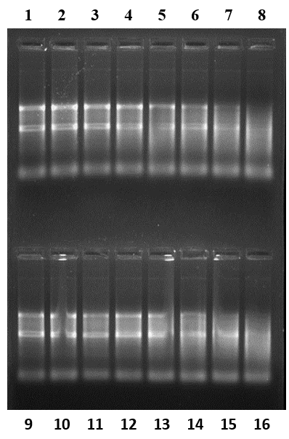

**Fig. S6.** RNA stability assay at varying temperature, no RNase added; treatment time ― 30 min.

Lanes 1–8: 1 µg RNA + 0.25 µg Thermo Scientific™ RiboLock

|  |  |  |  |  |  |  |  |
| --- | --- | --- | --- | --- | --- | --- | --- |
| **1** | **2** | **3** | **4** | **5** | **6** | **7** | **8** |
| 42.0 °C | 42.5 °C | 43.5 °C | 45.3 °C | 47.6 °C | 49.9°C | 52.1 °C | 54.4 °C |

Lanes 9–16: 1 µg RNA + 0.25 µg LoRI

|  |  |  |  |  |  |  |  |
| --- | --- | --- | --- | --- | --- | --- | --- |
| **9** | **10** | **11** | **12** | **13** | **14** | **15** | **16** |
| 42.0 °C | 42.5 °C | 43.5 °C | 45.3 °C | 47.6 °C | 49.9°C | 52.1 °C | 54.4 °C |

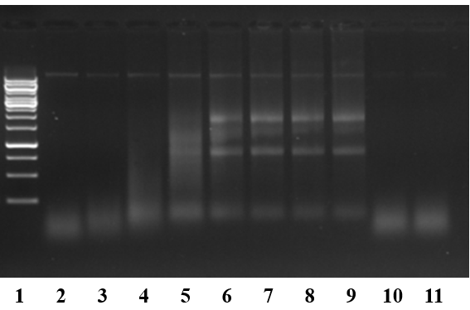

**Fig. S7.** RNA stability assay at varying temperature, treatment time ― 30 min.

Lane 1: Thermo Scientific™ GeneRuler 1kb DNA Ladder

Lanes 2–9: 1 µg RNA + 2.5 ng RNase A + 2 µg LoRI

|  |  |  |  |  |  |  |  |
| --- | --- | --- | --- | --- | --- | --- | --- |
| **2** | **3** | **4** | **5** | **6** | **7** | **8** | **9** |
| 57.0 °C | 56.0 °C | 54.1 °C | 50.7 °C | 46.6 °C | 43.3 °C | 41.1 °C | 40.0 °C |

Lanes 10–11: 1 µg RNA + 2.5 ng RNase A, no inhibitor added, incubated at 40.0 °C

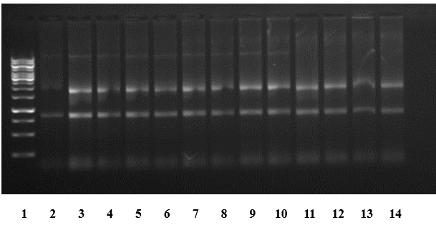

**Fig. S8.** RNA stability assay at varying temperature, no RNase added, treatment time ― 30 min.

Lane 1: Thermo Scientific™ GeneRuler 1kb DNA Ladder

Lanes 2–10: 1 µg RNA + 2 µg LoRI

|  |  |  |  |  |  |  |  |  |
| --- | --- | --- | --- | --- | --- | --- | --- | --- |
| **2** | **3** | **4** | **5** | **6** | **7** | **8** | **9** | **10** |
| 57.0 °C | 57.0 °C | 56.0 °C | 54.1 °C | 50.7 °C | 46.6 °C | 43.3 °C | 41.1 °C | 40.0 °C |

Lanes 11–12: 1 µg RNA, no RNase added, no inhibitor added, incubated at 40.0 °C and 57.0 °C, respectively.

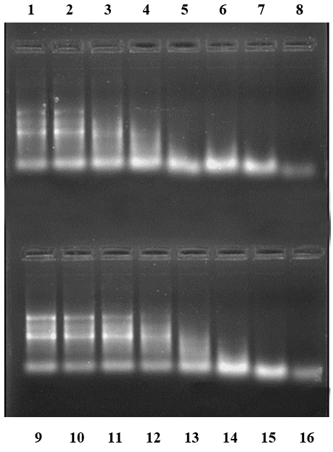

**Fig. S9.** RNA stability assay at varying temperature, treatment time ― 30 min.

Lanes 1–8: 1 µg RNA + 2.5 ng RNase A + 0.25 µg Thermo Scientific™ RiboLock

|  |  |  |  |  |  |  |  |
| --- | --- | --- | --- | --- | --- | --- | --- |
| **1** | **2** | **3** | **4** | **5** | **6** | **7** | **8** |
| 42.0 °C | 42.5 °C | 43.5 °C | 45.3 °C | 47.6 °C | 49.9°C | 52.1 °C | 54.4 °C |

Lanes 9–16: 1 µg RNA + 2.5 ng RNase A + 0.25 µg LoRI

|  |  |  |  |  |  |  |  |
| --- | --- | --- | --- | --- | --- | --- | --- |
| **9** | **10** | **11** | **12** | **13** | **14** | **15** | **16** |
| 42.0 °C | 42.5 °C | 43.5 °C | 45.3 °C | 47.6 °C | 49.9°C | 52.1 °C | 54.4 °C |

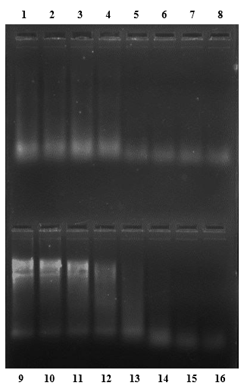

**Fig. S10.** RNA stability assay at varying temperature, treatment time ― 60 min.

Lanes 1–8: 1 µg RNA + 2.5 ng RNase A + 0.25 µg Thermo Scientific™ RiboLock

|  |  |  |  |  |  |  |  |
| --- | --- | --- | --- | --- | --- | --- | --- |
| **1** | **2** | **3** | **4** | **5** | **6** | **7** | **8** |
| 42.0 °C | 42.5 °C | 43.5 °C | 45.3 °C | 47.6 °C | 49.9 °C | 52.1 °C | 54.4 °C |

Lanes 9–16: 1 µg RNA + 2.5 ng RNase A + 0.25 µg LoRI

|  |  |  |  |  |  |  |  |
| --- | --- | --- | --- | --- | --- | --- | --- |
| **9** | **10** | **11** | **12** | **13** | **14** | **15** | **16** |
| 42.0 °C | 42.5 °C | 43.5 °C | 45.3 °C | 47.6 °C | 49.9 °C | 52.1 °C | 54.4 °C |

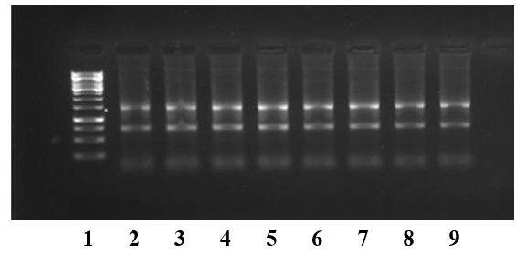

**Fig. S11.** RNA stability assay at varying temperature, no RNase added, treatment time ― 30 min.

Lane 1: Thermo Scientific™ GeneRuler 1kb DNA Ladder

Lanes 2–9: 1 µg RNA + 0.5 µg LoRI

|  |  |  |  |  |  |  |  |
| --- | --- | --- | --- | --- | --- | --- | --- |
| **2** | **3** | **4** | **5** | **6** | **7** | **8** | **9** |
| 51.0 °C | 50.4 °C | 49.1 °C | 47.0 °C | 44.3 °C | 42.2 °C | 40.7 °C | 40.0 °C |

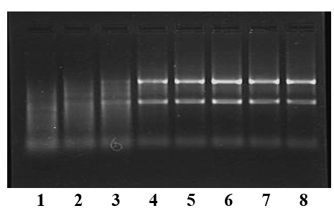

**Fig. S12.** RNA stability assay at varying temperature, treatment time ― 30 min.

Lanes 1–8: 1 µg RNA + 2.5 ng RNase A + 0.5 µg LoRI

|  |  |  |  |  |  |  |  |
| --- | --- | --- | --- | --- | --- | --- | --- |
| **1** | **2** | **3** | **4** | **5** | **6** | **7** | **8** |
| 51.0 °C | 50.4 °C | 49.1 °C | 47.0 °C | 44.3 °C | 42.2 °C | 40.7 °C | 40.0 °C |

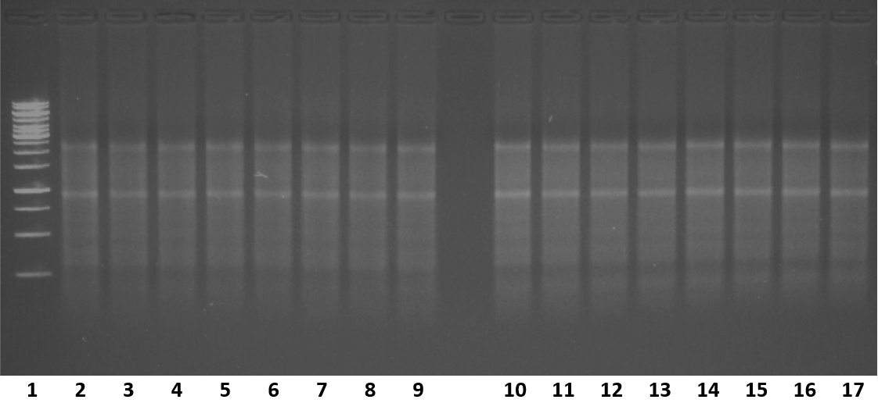

**Fig. S13.** RNA stability assay with varying amount of RNase A added, treatment at room temperature for 5 min.

Lane 1: Thermo Scientific™ GeneRuler 1kb DNA Ladder

Lanes 2, 10: 0.5 µg RNA

Lanes 3–9: 0.5 µg RNA premixed to 0.1 µg LoRI + RNase A (varying amount)

|  |  |  |  |  |  |  |
| --- | --- | --- | --- | --- | --- | --- |
| **3** | **4** | **5** | **6** | **7** | **8** | **9** |
| 5 ng | 2.5 ng | 1.25 ng | 0.6 ng | 0.3 ng | 0.15 ng | 0.075 ng |

Lanes 11–17: 0.5 µg RNA + 0.1 µg LoRI (5 U) premixed to RNase A (varying amount)

|  |  |  |  |  |  |  |
| --- | --- | --- | --- | --- | --- | --- |
| **11** | **12** | **13** | **14** | **15** | **16** | **17** |
| 5 ng | 2.5 ng | 1.25 ng | 0.6 ng | 0.3 ng | 0.15 ng | 0.075 ng |

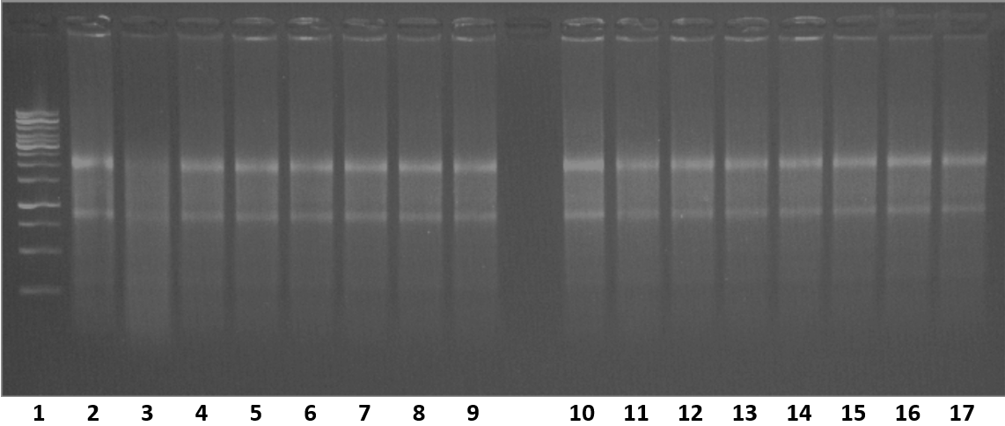

**Fig. S14.** RNA stability assay with varying amount of RNase A added, treatment at 37 °C for 30 min.

Lane 1: Thermo Scientific™ GeneRuler 1kb DNA Ladder

Lanes 2, 10: 0.5 µg RNA

Lanes 3–9: 0.5 µg RNA premixed to 0.1 µg LoRI + RNase A (varying amount)

|  |  |  |  |  |  |  |
| --- | --- | --- | --- | --- | --- | --- |
| **3** | **4** | **5** | **6** | **7** | **8** | **9** |
| 5 ng | 2.5 ng | 1.25 ng | 0.6 ng | 0.3 ng | 0.15 ng | 0.075 ng |

Lanes 11–17: 0.5 µg RNA + 0.1 µg LoRI (5 U) premixed to RNase A (varying amount)

|  |  |  |  |  |  |  |
| --- | --- | --- | --- | --- | --- | --- |
| **11** | **12** | **13** | **14** | **15** | **16** | **17** |
| 5 ng | 2.5 ng | 1.25 ng | 0.6 ng | 0.3 ng | 0.15 ng | 0.075 ng |

C:\Users\natalia.usman\Downloads\барсова катя\ВЕСТНИК\Figure S15.tif

**Fig. S15.** PCR (non)inhibition by LoRI assessed by Ct method. A 90 bp fragment of *GAPDH* was amplified from 100 pg of human genomic DNA in 25 µL reaction volume with a FAM-BHQ1 TaqMan probe. All tests were run in 5 technical replicates.

C:\Users\natalia.usman\Downloads\барсова катя\ВЕСТНИК\Figure S16.tif

**Fig. S16.** Fluorescence intensity plotted against RNA quantity in the assay; RFU, relative fluorescence units.

C:\Users\natalia.usman\Downloads\барсова катя\ВЕСТНИК\Figure S17.tif

**Fig. S17.** Inhibition curves for LoRI and Thermo Fisher™ RiboLock.

C:\Users\natalia.usman\Downloads\барсова катя\ВЕСТНИК\Figure S18.tif**Fig. S18.** Lineweaver–Burk plots of enzymatic reaction rate versus substrate concentration. **A.** LoRI at 197, 177, 157 and 0 nM; **B.** Thermo Fisher™ RiboLock at 252 and 0 nM.